Russian Rotarians Visit Rotary International Headquarters

The United States – Russia Intercountry Committee was chartered at Rotary Headquarters in June, 2007. Since that time this ICC has grown to be the largest Intercountry Committee in the Rotary world with Rotary districts representing over one third of the United States and all of Russia. Pictured here are several Rotarians from Russia who
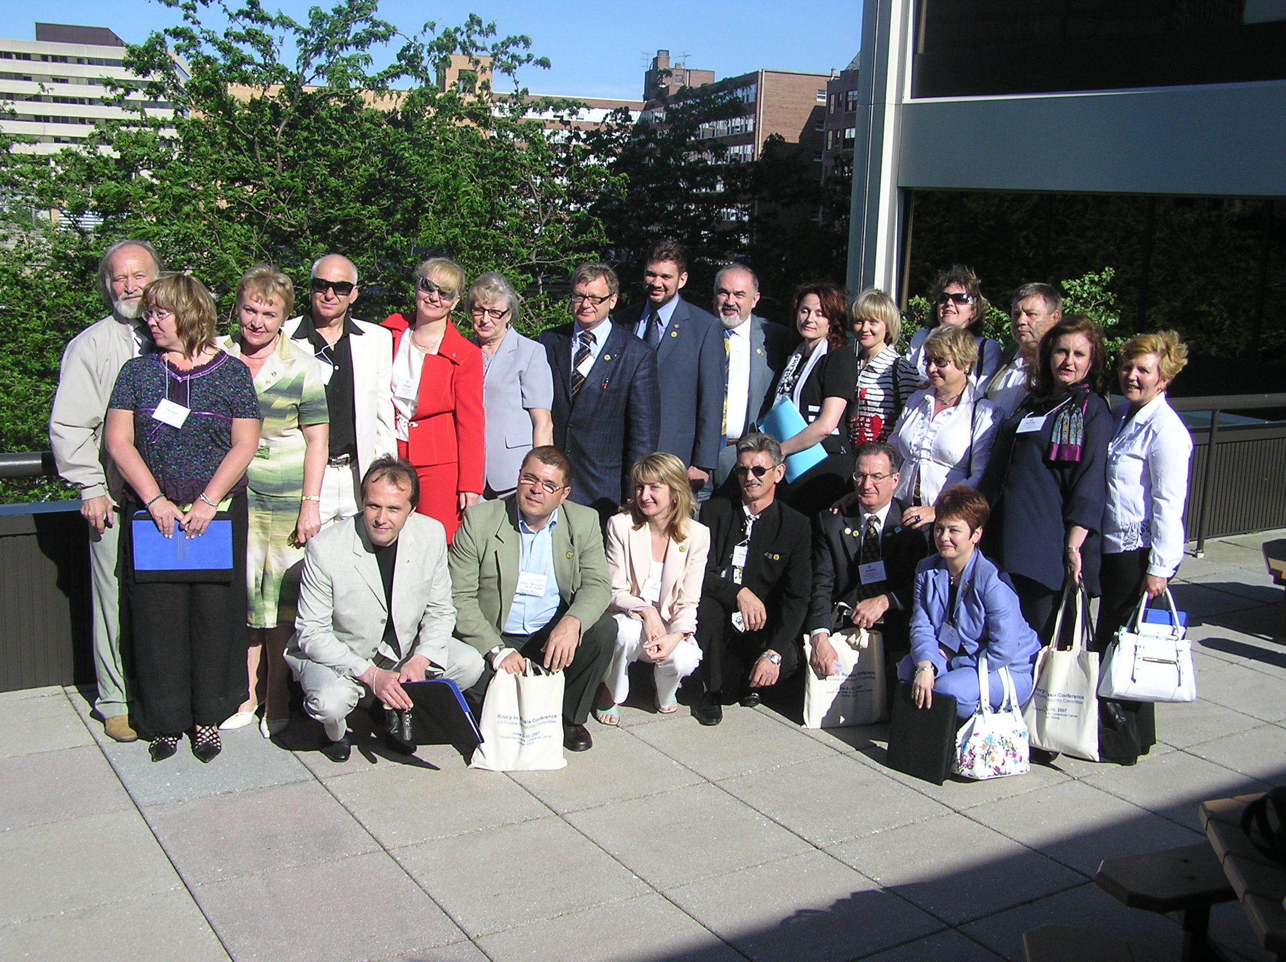
took part in the chartering ceremony on June 8, 2007. While this ICC is still in its formative stages, it is felt that the joint activities pursued by the 14 member districts offer great opportunities for collaboration between the districts from the two countries. Some of the planned activities of the organization will include joint projects, friendship and professional exchanges, expansion of the Rotary Youth Exchange Program, Group Study Exchanges and annual meetings that will rotate between the two countries.
The next meeting for the ICC is planned for 2010 in Arizona, hosted by Rotary District 5500

annual meeting
JUNE 14-15, 2009
Novosibirsk, russia

Sponsored by
Member Districts of the
United States-Russia Intercountry Committee

District 2220 – Russia, West of the Urals
District 5010 – Alaska, USA; Yukon Territory, Canada,
Russia, East of the Urals
District 5030 – Washington, USA
District 5440 – Wyoming, Parts of Colorado and
Nebraska, USA
District 5450 – Northern Colorado, USA
District 5490 – Arizona, Colorado, USA
District 5500 – Arizona, USA
District 5580 – Part of Ontario, Canada, North Dakota,
Parts of Minnesota and Wisconsin, USA
District 5690 – Parts of Kansas and Oklahoma, USA
District 5790 – Abilene, Texas, USA
District 5890 – Houston, Texas, USA
District 6840 – Parts of Louisiana and Mississippi, USA
District 7430 – Pennsylvania, USA
District 7870 – New Hampshire, USA

Program
United States --Russia ICC
June 14-15, 2009

SUNDAY, JUNE 14

08:00 | Registration | Nikolaevski Hall
09:00 | Breakfast | Sosnovka Hotel
10:00 | Plenary Session I | Nikolaevski Hall
- Conference Opening: PDG Jon Eiche & PDG Andrei Danilenko
Chairs, US and Russian Sections US-Russia ICC
10:15 | - Starting New Clubs in Russia and Rotary Basics  PDG Andrei Danilenko
11:30 | Coffee/Tea Break
11:50 | - Progress of Rotary in western Russia  DGE 2220 Nadia Papp
12:45 | Plenary Session II | Nikolaevski Hall
- Progress of Rotary in Russia, east of the Urals
District 5010 Governor Clyde Boyer & DGE Bill Hopper
14:00 | Lunch | Sosnovka Hotel
15:00 | Plenary Session III | Nikolaevski Hall
- Current Projects D5010
Speaker (Russian Rotarian)
- Current Projects D2220
Speaker DGE Nadia Papp
16:30 | Coffee/Tea Break
16:50 | - Open World Program  Speaker Lewis Madanick, Open World Leadership Center
18:30 | Dinner
19:00 | Cultural Entertainment | Petrovski Hall

MONDAY, JUNE 15

8:00 | Plenary Session IV | Nikolaevski Hall
- Exchanges Between Countries Panel
GSE, Friendship, Youth Exchange, Open World
Natalia Kunzer, Robert Walton, Evgenia Terekhova

- Establishing Twin Club Relationship Panel
PDGs Jon Eiche, Andrei Danilenko, DGE Bill Hopper
9:00 | Breakfast | Sosnovka Hotel
10:00 | Breakout Sessions by Topics
 | - Planning for the Future (Eastern) | Nikolaevski Hall
 | Chair: East of the Urals D5010 Rotarian Andrei Konuskok
 | - Planning for the Future (Western) | Vladimirovski Hall
 | Chair: DGE 2220 Nadia Papp
11:40 | Coffee/Tea Break
12:00 | Reconvene in Nikolaevskij Hall for brief group reports
12:30 | Rotary’s Public Image in Russia | Nikolaevskij Hall
 | Bob Tomlinson, RI Public Image Resource group
14:00 | Lunch | Sosnovka Hotel
15:00 | U.S.-Russia ICC Business Meeting | Nikolaevskij Hall
17:00 | Conclusion of Meeting
18:30 | Dinner | Hotel

